How to find Critical value correspond to 95% Confidence Level?

This table is on page 187

Let’s understand the table and the meaning of critical value Say Critical Value, z is 1.03

Now locate 1 in first column and go horizontally right below 0.03 [1 and 0.03 adds to 1.03]
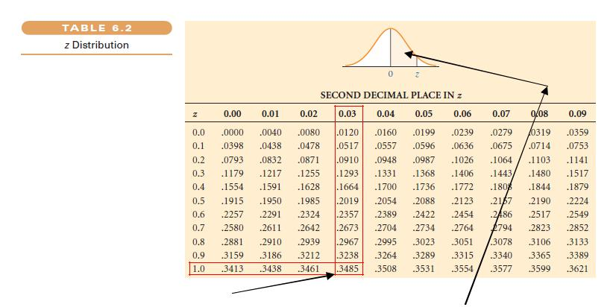

This way you will be able to find 0.3485 and this belongs to this shaded area

Exercise 1

Find shaded area for z = 0.58
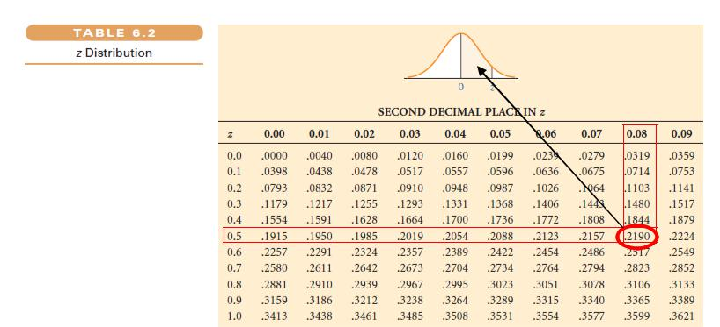

Dr Vinod on Z values from Normal Table 8971073111 vinodanalytics@gmail.com Page 1
Now you need to find Critical value of z correspond to 95% Confidence Level?

Step 1

Subtract 95 from 100. This is 5.

Step 2

Divide 5 into two halves (5/2 = 2.5%)
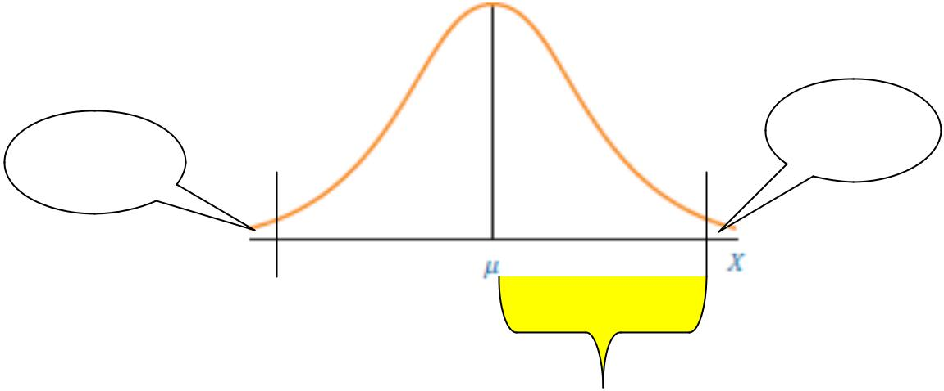

2.5 % or
2.5 % or 0.025
0.025

Step 3

How much is the area belongs to yellow shaded region in the curve?

Remember, this curve is a symmetrical curve. Meaning thereby, right half can be said as 0.50 or 50%. Refer page 185 of Ken Black
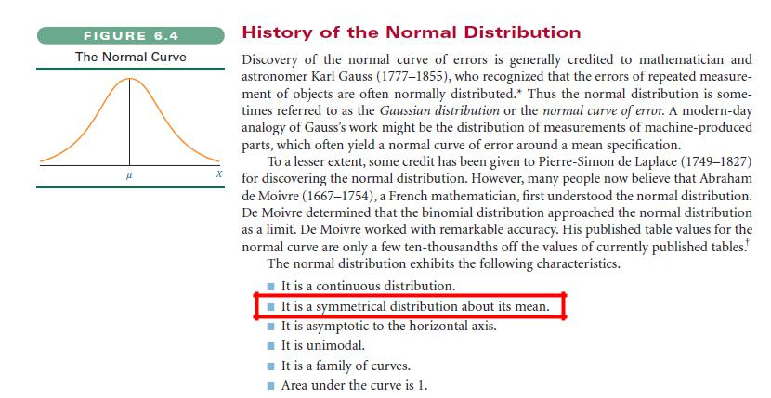

Dr Vinod on Z values from Normal Table 8971073111 vinodanalytics@gmail.com Page 2
So, can you do like this? 0.50 – 0.025 = 0.475
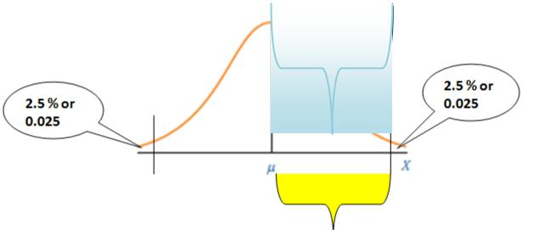

0.475

Step 4

Go to Page 187....can you locate 0.475 (or the most nearest number in table)
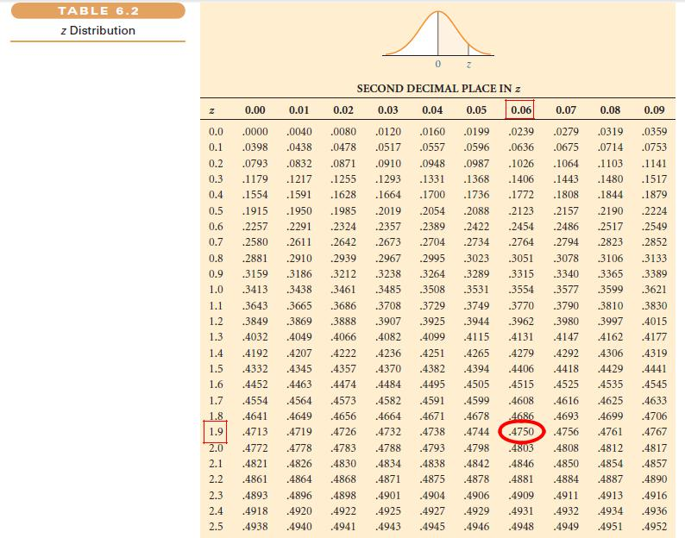

Step 5

Now start from 0.4750....move left and find 1.9....then again start from 0.4750 and go up and locate

0.06.

HENCE CRITICAL VALUE FOR 95% CONFIDENCE LEVEL IS 1.96

Dr Vinod on Z values from Normal Table 8971073111 vinodanalytics@gmail.com Page 3
Exercise 2

Find critical value of z for:

- 90 % Confidence Level
Step1: Subtract 90 from 100. This is 10.
Step 2: Divide 10 into 2 halves (10/2 = 5%)
Step 3: 5% = 5/100 = 0.05
Since, area under the curve is 1. Area on one side of the curve is 50% or
0.50
So, 0.50 - 0.05 = 0.45
Step 4: Go to Table 6.2 z Distribution to locate 0.45 (or the most nearest number in
Table 0.4505)
Step 5: Move vertical downwards till 1.6 in column z and move right horizontally in
same row to locate 0.45 under column 0.05
HENCE CRITICAL VALUE FOR 90% CONFIDENCE LEVEL IS 1.6

- 80% Confidence Level
Step1: Subtract 80 from 100. This is 20.
Step 2: Divide 20 into 2 halves (20/2 = 10%)
Step 3: 10% = 10/100 = 0.1
Since, area under the curve is 1. Area on one side of the curve is 50% or
0.50
So, 0.50 - 0.10 = 0.40
Step 4: Go to Table 6.2 z Distribution to locate 0.40 (or the most nearest number in
table 0.3997)
Step 5: Move vertical downwards till 1.2 in column z and move right horizontally in
same row to locate 0.4015 under column 0.08
HENCE CRITICAL VALUE FOR 90% CONFIDENCE LEVEL IS 1.2

- 99% Confidence Level
Step1: Subtract 99 from 100. This is 1.
Step 2: Divide 1 into 2 halves (1/2 = 0.5%)
Step 3: 0.5% = 0.5/100 = 0.005
Since, area under the curve is 1. Area on one side of the curve is 50% or
0.50
So, 0.50 - 0.005 = 0.495
Step 4: Go to Table 6.2 z Distribution to locate 0.495 (or the most nearest number in table 0.4951)
Step 5: Move vertical downwards till 2.5 in column z and move right horizontally in
same row to locate 0.4951 under column 0.08
HENCE CRITICAL VALUE FOR 99% CONFIDENCE LEVEL IS 2.5

Dr Vinod on Z values from Normal Table 8971073111 vinodanalytics@gmail.com Page 4

